Tongji - Development

**Technical Design Document**

(Version 4)

2015/6/22

Table of Contents

1. Overview 3

2. Requirements 3

2.1. Brief 3

2.2. Reference 3

3. Dependencies 3

4. Existing Technology 4

4.1. Features 4

4.2. Reference 4

5. Implementation details 4

5.1. Map Editor 4

5.2. Level loading 4

5.3. Element Design 4

5.4. AI Design 4

5.5. Sound Develop 4

5.6. Animation Develop 4

6. Proof 5

7. Issues 5

8. Risks 6

9. Estimates 6

# Overview

This system is a game based on the Unity3d engine. The game’s concept is according to Bomber Man and we’re trying to make it more interesting and funnier. Our goals are to finish the whole game including 3 levels which should be harder by each level. The purpose of this game is of course to make people love playing it and to finish our course project.

Differ from other bomber man game, this game will much more like a fps game, such as PROTOL and COD, which means, player will not only player this game, but also enjoy the plot.

# Requirements

## Brief

* The game is based on Bomber man but we will recreate the background and make the game in 3D
* The game will be developed using Unity3D
* The game will developed on script which is will make the game like a story.
* The story script will be as an enclose with TDD.
* Whole the game also should have a map editor which will make the map design more easier.
* Map information should contain the element position player life, tool rate, map visibility.
* The scene should be reused, each level will be loaded on the same “room”.
* Game element will contain “Canon floor”, “Breakable cube”, “Unbreakable cube”, “Robot”, “Player”, “Tools”. All the elements will define in Implementation Detail.
* Depended on different level we should design different AI.
* Sound and scene change animation also should be design.

## Reference

* We want to recreate the playing method to make the game played not in an original way
* As we are not good in constructing 3D models, we are planning to search for some free 3d models and music on the Internet and use them
* All the technical reference will find in Virtuos 2015 game course PPT.

# Dependencies

* As our group don’t have much developing experence in 3D game area, we will try to find some examples or instructions to help us learn better and faster about the whole process
* One of our group members has been learning about Unity3D but we are all beginning learners. We are trying to find a faster way to write the codes correctly, such as some open-sourced codes on which we can just modify.
* We’re not sure whether 3D models are hard to find. We can build the gaming scenes and bombs by ourselves

# Existing Technology

## Features

QQtang

Gaming basics

* Our game style will be generated based on the game mode of qqtang and added with some of our original ideas to make it different.

Characters&Bomb appearences

* There are lots of characters and different bomb appearences in qqtang, we’ll consider to make several models so that players can choose.

Counter Strike

First-person

* It is fun to think if we play bomberman in first-person sight. So we are thinking how to roll the camera.

## Reference

* Some tutorial materials about Maya, Unity3D on the Internet
* Open-sourced game projects built basing on Unity3D
* In the map create part, the reference is from Tank Game.

# Implementation details

## Map Editor

Description:

This part is focus on give programmer or designer a tool to build a map quickly and obviously.

Function:

Drag: User could drag the cube to the map, and editor will mark the position and the cube type of it. The code like this:

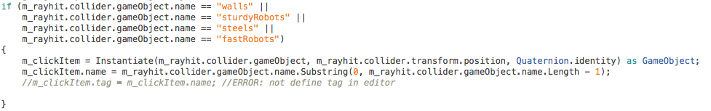

Save: Map should be save as normal file such as XML or some thing else.

the code like this:

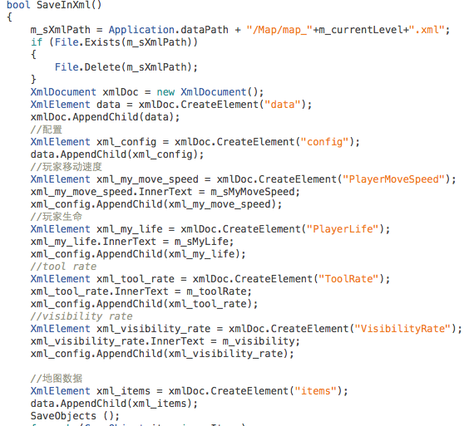

Load: When user wants to redesign the map it could load the map. the code like this:

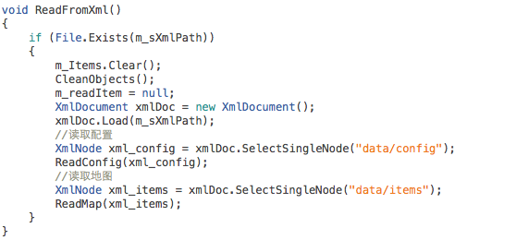

## Level Loading

There are 3 level of map, so we should load level or map in same scene, we build a script like this , it just like load map in map editor. But we change the element in it , because map editor is a 2D while bomber man is 3D. All the elements are different.



And the frame work of map is just like this:



## Element Design

We have such elements in the game:

* Canon floor: Instead of bomber, canon could shot to four direction and could rise and fall. Hence there are at least 4 part in class Canon

***ChangeMateiral() could change material when mouse point to it.***

***Rise(int time) rise function***

***Fall(int time) fall function***

***Shot(int time, int distance) shot function***

* Breakable cube: those cube could be destroyed and produce tools. Hence the main function of it is :

***Break(float toolRate) paly the destroy animation and build new tool in current position.***

* Unbreakable cube: this is unbreakable cube with no function or class.
* Tools: we have Faster, Life+1,Longer,Far those 4 tools, every tools will change player’s attribute directly.
* Elevator: when player finish one level he/she will ride elevator to go down to next level. So the function of it are:

***Show() elevator show up***

***Run() go down to next level***

## AI Design

AI is a most important part in the game. We use UML to design it:

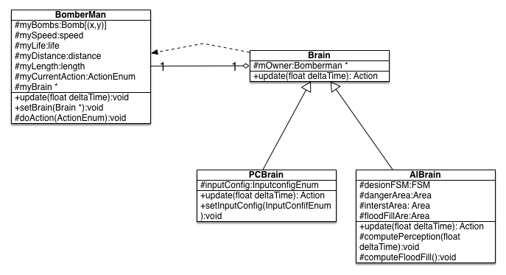

**Memory Implications:**

<How will this effect Memory, it may not>

**Performance Implications:**

<How will this effect Performance, it may not>

**Networking Implications:**

<How will this effect Networking, it may not>

|  |
| --- |
| **Hint –** <These things may be needed to think. >  Thread usage (single/multi-threaded)  Supported platforms (PC, 360, PS3, PSP, WII…) |

# Proof

There are two method to perform our test, Black box and White box.

| No. | QualityRisk | Tech.Risk | Bus.Risk | Risk Pri.# | Extent of Testing |
| --- | --- | --- | --- | --- | --- |
| 1.00 | Performance |  |  |  |  |
|  | Cannon Cannot Setup | 2 | 3 | 6 | Broad |
|  | Player cannot control himself | 2 | 3 | 6 | Broad |
|  | Story cannot trig | 2 | 4 | 8 | Broad |
|  | Sound cannot play | 2 | 3 | 6 | Broad |
|  | Robot cannot move | 3 | 4 | 12 | Cursory |
|  | Robot cannot setup cannon | 4 | 4 | 16 | Opportunity |
|  | Game cannot start | 4 | 5 | 20 | Opportunity |
|  | Dead and Success cannot trig | 3 | 4 | 12 | Cursory |
|  | Prop didn’t work | 3 | 4 | 12 | Cursory |
| 2.00 | Functionality |  |  |  |  |
|  | Map information is wrong | 3 | 2 | 6 | Broad |
|  | Cannot load and save map | 4 | 3 | 6 | Opportunity |
|  | AI state cannot change correctly | 5 | 4 | 20 | Opportunity |
|  | Path finding is wrong | 5 | 5 | 25 | Report Bugs |
|  | Level Loading Wrong | 2 | 2 | 4 | Broad |
| 3.000 | UI |  |  |  |  |
|  | UI Jump is wrong | 3 | 5 | 15 | Opportunity |
| 4.000 | Supportability |  |  |  |  |
|  | Cannot support in Windows or MacOS | 4 | 5 | 20 | Opportunity |

Before we did our test, we should do the risk analysis.

After the risk analysis, we could start and design some test cases.

<Performance>

This part, we mainly use black box test, testers trig those event and get the results to judge whether it is correct.

<Functionality>

This part, we use white box to test.

Map information:

We use script to test whether map file is correct.

Some thing like, we load map and find whether all the node could be found.

The Pass/Fail Criteria is: Correct or Failed.

AI State change:

We could take all the states as input, to check whether output is as same as we want

AI path finding:

The test case could be like this:

We input the goal point, and run the Algo, and see whether the output vector is the best one.

<UI>

Also use black box to test

<supportability>

Also use black box to test, Install in different operation system

# Issues

* The size of UI (1080x1920 or 1024x920)
* The type of Model(Fbx)
* The type of sound(MP3 or WVA)
* The type of texture(png, gif)
* Whether to use third part API
* How to get fluency and quality at same time
* How to avoid all the Potential bugs

# Risks

You can see risk analysis in 6 part: Proof

# Estimates

Task time table is in folder as attachment